SIMATS ENGINEERING

CSA15 – CLOUD COMPUTING AND BIG DATA ANALYTICS

ASSIGNMENT 3 – CO3
OBE-Based Evidence Principle

Design a Cloud-Based Collaborative Solution
CO3: Implement cloud-based solutions using cloud storage, web APIs, and platform services for real-world applications.

Field | Details | Field | Details
Student Name | K.Sasidhar Reddy | Register Number | 192525140
Department / Section | B.Tech(AI&ML) | Academic Year / Semester | 2026
Faculty Name | Dr.R.Latha | Nature of Assignment | Individual
Duration | 1 Week | Total Marks | 50
Submission Date |  | Evaluation Date

MARK SHEET (Rubric-based evaluation)
Task | Title | Max | Awarded | Evidence / evaluation focus
1 | Accessing Cloud Services through Different Methods | 6 |  | Access-method diagram; demonstration; screenshots; comparison
2 | Cloud Platforms and Web Applications | 7 |  | Two platforms; interaction diagram; app demonstration; evaluation
3 | Web APIs for Cloud Access | 7 |  | API design; executable client; two requests; responses
4 | Cloud Security and Network Access | 7 |  | Secure-access architecture; threats; authentication; mitigations
5 | Collaboration Using Cloud-Based Services | 6 |  | Shared workspace; permissions; edits; contribution evidence
6 | Integrated Cloud Access and Collaboration Mini Investigation | 7 |  | Scenario; architecture; prototype; two user tests; evaluation
7 | Day-4 Design Challenge: Cloud-Based Collaborative Solution | 10 |  | Two independent proposals; comparison; joint design; validation; defence
 | TOTAL | 50 |  | Percentage:

OVERALL REMARKS

K.Sasidhar Reddy  Student Signature | _______________  Faculty Signature | _______________  Program Director

MANDATORY SUBMISSION EVIDENCE CHECK

✓ = Present in documented answer; P = Partly present; ✗ = Missing / not satisfied
Task | Evidence expected | Status | Evaluator note
1 | Three access methods, client–network–cloud diagram, demonstration and observations |  | Access-method classification and practical access screenshots to be checked.
2 | Two-platform comparison, interaction diagram and cloud web-app demonstration |  | Platform mapping, user-action sequence and local-versus-cloud evaluation to be checked.
3 | API flow, program, two request inputs, responses and execution evidence |  | Code, actual request/response outputs and analysis to be checked.
4 | Secure-access flow, four security considerations, threat and mitigation analysis |  | Authentication, authorization and secure-communication evidence to be checked.
5 | Shared workspace, permission settings, two collaborative activities and contributions |  | Verify shared editing, user roles, permissions and contribution screenshots.
6 | Integrated scenario, architecture, prototype, two user scenarios and results |  | Verify cloud access, collaboration workflow, tests and limitations.
7 | Two initial proposals, comparison record, joint design, tests and cross-defence |  | Verify independent proposals, joint decisions, observed results and both students’ understanding.

IMPLEMENTATION EVIDENCE CHAIN
Evidence item | Status | Observation
Cloud access methods |  | Browser, mobile and API access methods explained.
Cloud platforms |  | Two cloud platforms and their applications compared.
Cloud access demonstration |  | Actual screenshots need verification.
Web API implementation |  | Program and execution outputs need verification.
Cloud security |  | Authentication, authorization and security measures explained.
Cloud collaboration |  | Shared workspace and editing evidence need verification.
Mini-project |  | Design included; practical testing needs verification.
Day-4 design challenge |  | Individual proposals, joint design and validation need verification.
Student contributions |  | Contributions of both students need confirmation.
Screenshots |  | Original execution screenshots required.

SUBMISSION CHECKLIST (Not Separately Marked)
Requirement | Status
All 7 questions answered | ☐ Yes ☐ Partly ☐ No
Cloud access methods explained | ☐ Yes ☐ Partly ☐ No
Cloud architecture diagrams included | ☐ Yes ☐ Partly ☐ No
Two cloud platforms compared | ☐ Yes ☐ Partly ☐ No
Web API program and testing completed | ☐ Yes ☐ Partly ☐ No
Cloud security explained | ☐ Yes ☐ Partly ☐ No
Cloud collaboration demonstrated | ☐ Yes ☐ Partly ☐ No
Mini-project completed and tested | ☐ Yes ☐ Partly ☐ No
Day-4 design challenge completed | ☐ Yes ☐ Partly ☐ No
Student A and B contributions recorded | ☐ Yes ☐ Partly ☐ No
Screenshots and practical evidence attached | ☐ Yes ☐ Partly ☐ No
Viva recommended | ☐ Yes ☐ No

CLOUD COMPUTING AND BIG DATA ANALYTICS
ASSIGNMENT 3 – CO3

CO3: Implement cloud-based solutions using cloud storage, web APIs, and platform services for real-world applications.

Mode: Pair Work – 2 Students per Group
Duration: 1 Week Total Marks: 50

OBE-Based Evidence Principle

The assignment requires students to demonstrate measurable evidence of:
Understand → Design → Implement → Demonstrate → Analyse → Evaluate
Both students must understand the complete assignment. Students should not simply divide questions between them. Individual responsibilities are assigned within each question so that the contribution and attainment of CO3 can be independently verified.

Q1 – Accessing Cloud Services through Different Methods 6 Marks
Shared Group Work
Together, the pair must:
- Identify different methods of accessing cloud services.
- Study browser-based/cloud console access.
- Study access through mobile applications.
- Study access through APIs.
- Identify the role of Internet/network connectivity.
- Select one suitable cloud service for demonstration.
Student A – Access Method Design
Student A must individually:
- Identify and classify at least three cloud access methods.
- Prepare a simple architecture/flow diagram showing:
Client → Network → Cloud Service
- Explain how a user accesses the selected cloud service.
- Identify the hardware/software requirements.
- Explain the role of the client and network.
- Justify which access method is most suitable for the selected application.
Student B – Practical Evidence
Student B must individually:
- Demonstrate access to a cloud service using one selected method.
- Record the steps/screenshots as evidence.
- Test the access using different devices or access methods where possible.
- Record observations such as accessibility, response, and usability.
- Identify one limitation encountered during access.
- Explain how the limitation can affect cloud usage.
Cross-Verification
Student A must be able to explain Student B's practical demonstration.
Student B must be able to explain Student A's access architecture.
Evidence Expected: Architecture diagram + screenshots/observations + comparison.

Q2 – Cloud Platforms and Web Applications 7 Marks
Shared Group Work
Together:
- Select two cloud platforms/services.
- Identify the web applications available through them.
- Study how users interact with the applications.
- Identify the cloud resources/services supporting the application.
- Prepare a comparative observation.
Student A – Platform Analysis
Student A must individually:
- Identify the major components of the selected cloud platform.
- Explain how the platform supports web applications.
- Map the user request to the cloud service.
- Explain the role of the Internet, server/cloud infrastructure and application.
- Prepare a simple interaction diagram.
Student B – Application Investigation
Student B must individually:
- Select one real-world cloud-based web application.
- Demonstrate its major functions.
- Record the sequence of user actions.
- Identify where cloud access is involved.
- Collect screenshots/evidence of the demonstration.
- Analyse the benefits of using the cloud-based application.
Joint Evaluation
Together answer:
If the same application were installed and operated only on a local computer, what limitations might users experience compared with accessing it through the cloud?
Evidence Expected: Platform/application mapping + demonstration evidence + evaluation.

Q3 – Web APIs for Cloud Access 7 Marks
Shared Group Work
Together:
- Study the concept of a Web API.
- Identify how APIs enable application-to-cloud communication.
- Select a simple publicly accessible API or cloud API.
- Develop a small program/client to send a request.
- Observe and record the response.
Student A – API Design and Understanding
Student A must individually:
- Explain the purpose of the selected API.
- Identify the request and response components.
- Represent the API communication using a flow diagram.
- Explain the role of:
  - Client
  - API request
  - Cloud/server
  - API response
- Explain how APIs enable programmatic cloud access.
Student B – Implementation and Evidence
Student B must individually:
- Implement a simple API request using Python or another suitable language.
- Execute the program.
- Record input/request and output/response.
- Test at least two different requests or inputs.
- Capture execution evidence.
- Analyse the observed results.
Joint Analysis
Together determine:
Why is API-based access useful when a large number of users/applications need to communicate with a cloud service automatically?
Evidence Expected: Program + execution screenshots + request/response evidence + analysis.

Q4 – Cloud Security and Network Access 7 Marks
Shared Group Work
Together:
- Identify security issues involved in accessing cloud services.
- Study authentication and authorization.
- Study secure network communication.
- Identify possible threats during cloud access.
- Prepare a secure cloud-access scenario.
Student B – Security Design
Student B must individually:
- Identify at least four security considerations for cloud access.
- Explain authentication and authorization.
- Explain the importance of secure communication.
- Design a secure access flow:
User → Authentication → Network → Cloud Service → Authorization → Resource
- Identify possible points of attack.
- Suggest suitable security measures.
Student A – Security Investigation
Student A must individually:
- Investigate a practical cloud-access security scenario.
- Demonstrate or document a suitable authentication mechanism where feasible.
- Compare secure and insecure access situations conceptually.
- Record observations.
- Explain how poor security practices can affect cloud users and data.
Joint Evaluation
Together answer:
If cloud access is available from anywhere through the Internet, what additional security measures are necessary compared with a local application?
Evidence Expected: Secure-access architecture + threat identification + mitigation analysis.

Q5 – Collaboration Using Cloud-Based Services 6 Marks
Shared Group Work
Together:
- Select a cloud collaboration platform/service.
- Create a shared document/folder/project space.
- Configure appropriate sharing permissions.
- Perform collaborative editing.
- Record the collaboration process.
Student A – Collaboration Design
Student A must individually:
- Identify the collaboration requirements.
- Design a suitable cloud collaboration workflow.
- Explain:
  - Sharing
  - Concurrent access
  - Version control
  - Permission management
- Identify the roles of different users.
- Justify the selected sharing permissions.
Student B – Collaborative Implementation
Student B must individually:
- Participate in the shared cloud workspace.
- Perform at least two collaborative activities.
- Record evidence of contribution.
- Demonstrate sharing/permission settings.
- Observe how changes made by users are reflected.
- Identify one collaboration issue and suggest a solution.
Cross-Understanding
Student B must explain:
How does cloud collaboration reduce the need to exchange multiple copies of the same file?
Student A must explain:
What problems can occur if incorrect sharing permissions are given?
Evidence Expected: Shared workspace + contribution evidence + permission screenshots + observations.

Q6 – Integrated Cloud Access and Collaboration Mini Investigation 7 Marks
Students must design a small real-world scenario that requires both cloud access and cloud collaboration.
Suggested Scenarios
Choose one:
- Cloud-based Student Project Management
- Online Student Attendance and Faculty Collaboration
- Cloud-Based Event Management
- Cloud-Based Assignment Submission and Evaluation
- Cloud-Based Hospital Appointment Coordination
- Cloud-Based Disaster Information Sharing
- Cloud-Based College Placement Coordination
Student A – System Design
Student A must individually:
- Define the problem.
- Identify users.
- Identify cloud access methods.
- Identify required cloud services.
- Design the system architecture.
- Explain how users access the system.
- Explain how users collaborate.
Student B – Evidence and Evaluation
Student B must individually:
- Develop a small prototype/mock-up/workflow where feasible.
- Demonstrate at least one cloud access mechanism.
- Demonstrate one collaboration mechanism.
- Record screenshots/evidence.
- Test the proposed solution using at least two user scenarios.
- Analyse the results.
- Identify limitations and possible improvements.
Joint Evaluation
Together answer:
How does combining cloud access and cloud collaboration improve the efficiency of the proposed system?

Q7 – DAY-4 DESIGN CHALLENGE

Design a Cloud-Based Collaborative Solution 10 Marks

This question must be solved collaboratively.

Neither student should independently prepare the complete solution and combine it later.

Stage 1 – Independent Design Proposal
Before discussing with each other:
Student A independently proposes:

- Problem definition
- Target users
- Cloud access method
- Required cloud services
- Collaboration mechanism
- Basic architecture
Student B independently proposes:

- Problem definition
- Target users
- Cloud access method
- Required cloud services
- Collaboration mechanism
- Basic architecture
Both initial proposals must be retained as evidence.

Stage 2 – Compare the Two Designs

Together discuss:
- Where the designs agree
- Where they differ
- Strengths and weaknesses
- Security concerns
- Accessibility
- Collaboration requirements
- Missing components
- Which ideas should be retained
Prepare a Design Comparison Record.

Stage 3 – Joint Final Design
Develop the final cloud-based solution.
The final design must identify:
- Problem
- Users
- Cloud access method
- Network requirements
- Cloud service/platform
- Web application/API requirement
- Collaboration mechanism
- Authentication/security
- Data/resource sharing
- Complete system workflow
Prepare an architecture such as:

Users → Client → Internet/Network → Cloud Platform → Application/API → Shared Resources

Stage 4 – Validation

Student A – Technical Validation

Student A must:
- Explain the selected cloud access method.
- Justify the platform/service selection.
- Explain the system architecture.
- Explain how API/web access is used, if applicable.
- Analyse the suitability of the design.

Student B – Experimental Validation

Student B must:
- Design test cases.
- Demonstrate the solution/workflow.
- Test different users/access conditions.
- Record observations.
- Present screenshots or other evidence.
- Compare expected and observed behaviour.

Stage 5 – Cross-Defence

Student A must explain:
What experimental evidence supports the group's cloud design?

Student B must explain:
Why was the selected cloud access and collaboration approach chosen?

Stage 6 – Joint Evaluation

Together determine:
- Benefits of the proposed cloud solution
- Access-related limitations
- Collaboration benefits
- Security risks
- Scalability considerations
- Possible improvements
- Situations where the proposed approach may not be appropriate
Final Question

What characteristics should a system designer consider before selecting cloud-based access and collaboration for a real-world application?

CONTRIBUTION RECORD

Each pair must include the following table at the end of the submission.
Question | Student A –  Primary Contribution | Student B –  Primary Contribution | Joint Work
Q1
Q2
Q3
Q4
Q5
Q6
Q7
The contribution record must reflect the actual work completed.
Primary contribution does not mean exclusive responsibility. Both students are accountable for the complete assignment.

INDIVIDUAL VERIFICATION – OBE EVIDENCE
Faculty may select any question or component for individual verification.
Each student must be able to:
- Explain the cloud access method.
- Explain the role of client, network and cloud service.
- Explain web application/API access.
- Explain security considerations.
- Demonstrate cloud collaboration.
- Interpret experimental evidence.
- Justify design decisions.
- Respond to a modified requirement or scenario.
A student should not answer:
“My partner did this section.”
Understanding of the complete submitted work is mandatory.

RECOMMENDED FACULTY VERIFICATION MODEL – VIVA
For each student, conduct a brief 4–5 minute verification.
Question 1 – Primary Responsibility
Ask one technical question from the component for which the student had primary responsibility.
Question 2 – Partner's Responsibility
Ask one question from a component primarily completed by the partner.
Question 3 – Transfer Question
Modify a condition and ask the student to reason about the consequence.
Examples:
“If Internet connectivity becomes unreliable, how would it affect cloud access?”
“If a shared cloud document is given editing permission to everyone, what problems could occur?”
“If the API becomes unavailable, how would your application behave?”
“If a user is authenticated but does not have permission to access a resource, what should happen?”
This provides individual evidence of CO3 attainment without requiring two completely separate assignments.

OBE Evidence Mapping
CO3 Component | Assignment Evidence
Build methods to access cloud | Q1, Q2, Q3
Access through platforms/web applications | Q2
Programmatic/API-based access | Q3
Secure cloud access | Q4
Collaboration within cloud | Q5
Apply cloud access + collaboration | Q6
Design and evaluate a cloud solution | Q7
Individual attainment | Viva + contribution record
Practical evidence | Screenshots, programs, observations, test results
Higher-order learning | Design, analysis, evaluation and transfer questions

Q1 – Accessing Cloud Services through Different Methods

Shared Group Work
- Access methods studied: (1) Browser / cloud console, (2) Mobile application, (3) Web API / programmatic access (REST, SDK, CLI).
- Role of connectivity: Cloud services run in remote data centres, so every access needs Internet/network connectivity (Wi-Fi, broadband, 4G/5G). Bandwidth, latency and reliability of the network decide the quality of the experience.
- Service selected for demonstration: Google Drive (cloud storage service).

Student A – Access Method Design

1. Classification of cloud access methods
Access method | Client used | How it works | Typical users
Browser / Cloud console | Chrome, Edge, Firefox | User opens drive.google.com / AWS or Azure console; HTTPS page is rendered; actions are sent to the cloud as web requests. | Students, office users, administrators
Mobile application | Android / iOS app (Google Drive app) | Installed app authenticates with the account and syncs files over mobile data or Wi-Fi; supports offline marking and camera upload. | Users on the move
Web API / CLI / SDK | Python script, Postman, gcloud/aws CLI | Program sends HTTP requests (GET/POST) with a token; cloud returns JSON. Allows automation without a human interface. | Developers, automated systems

2. Architecture: Client → Network → Cloud Service
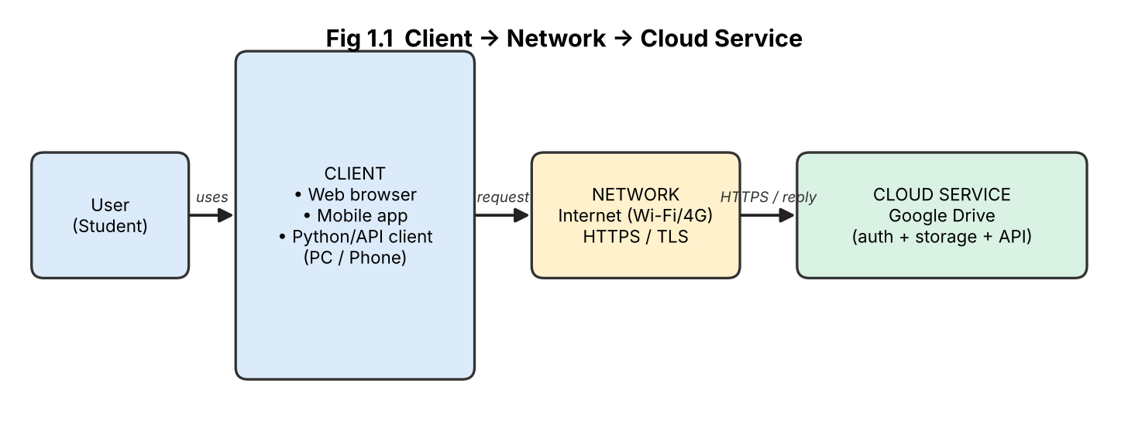
Figure 1.1 – Client → Network → Cloud Service

3. How a user accesses Google Drive
- The user opens the browser/app on a device (client) and enters drive.google.com.
- DNS resolves the address; a secure HTTPS (TLS) connection is made over the Internet.
- The user logs in (Google account + 2-step verification); the cloud service verifies identity.
- Google Drive servers return the file list; uploads, downloads and sharing are sent as requests and stored in Google's data centres with replication.

4. Hardware / software requirements
Item | Hardware | Software
Client | PC/laptop/smartphone with 2 GB+ RAM, display, input | Modern browser (Chrome/Edge) or Drive mobile app, OS (Windows/Android/iOS)
Network | Wi-Fi / broadband / mobile data (≥ 1 Mbps recommended) | TCP/IP, HTTPS/TLS, DNS
Cloud | Provider's servers, storage, load balancers (not owned by user) | Google account, Drive service, authentication service, API

5. Role of client and network
- Client: provides the user interface, captures user actions, encrypts the request and displays the results. It needs no heavy storage or processing because the work is done in the cloud.
- Network: carries requests and responses between client and cloud. Its speed and reliability decide upload/download time and whether the service is reachable at all.

6. Most suitable access method
For file storage and sharing by students, the browser/mobile-app method is most suitable: no installation or programming skill is needed, it works on any device, and the interface supports upload, preview and sharing. API access is best only when automation is required.

Student B – Practical Evidence

1. Steps followed to access Google Drive
Step | Action performed
1 | Opened Chrome on the laptop and typed drive.google.com.
2 | Signed in with the Google account (password + 2-step verification code).
3 | Clicked New → File upload and uploaded a sample file (CO3_test.pdf).
4 | Created a folder 'CO3_Assignment' and moved the file into it.
5 | Opened the same account in the Drive Android app and checked that the file/folder appeared.
6 | Signed out and noted the sign-in behaviour on both devices.


Screenshot 1.1 – Google Drive opened in the browser after login

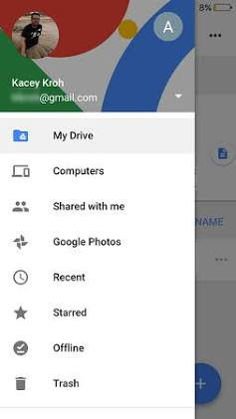
Screenshot 1.2 – Same folder seen in the Drive mobile app

2. Testing on different devices / methods
Device / method | Accessibility | Response | Usability observation
Laptop – browser | Direct login, no installation | Page loaded in about 2 s on Wi-Fi | Full features: upload, share, version history; easiest for large files
Smartphone – Drive app | Install once, auto sign-in | Folder opened in about 3 s on 4G | Touch-friendly; small screen makes editing and multi-select slower
Smartphone – browser | Opened mobile site | Slower than app | Redirects to the app for many actions

Observation: the same files are visible on all devices instantly, which proves that data is stored in the cloud and not on the device.

3. Limitation encountered and its effect
Limitation: When Wi-Fi was switched off, the Drive page could not be refreshed and new files could not be uploaded; only files marked 'Available offline' could be opened.
Effect on cloud usage: Cloud services depend on the Internet. Poor or no connectivity causes delays, failed uploads and loss of productivity; this is a reliability and availability limitation, so important files should be made available offline.

Cross-Verification
Student A can explain Student B's demonstration (login → upload → sync across devices), and Student B can explain Student A's Client → Network → Cloud architecture and the three access methods.

Q2 – Cloud Platforms and Web Applications

Shared Group Work
Two cloud platforms selected: Google Cloud / Google Workspace and Microsoft Azure / Microsoft 365.
Aspect | Google Cloud / Workspace | Microsoft Azure / Microsoft 365
Web applications | Gmail, Google Docs, Sheets, Slides, Drive, Meet, Forms | Outlook, Word Online, Excel Online, PowerPoint Online, OneDrive, Teams
User interaction | Browser or mobile app; sign in with Google account | Browser or mobile app; sign in with Microsoft account
Supporting cloud resources | Compute Engine, Cloud Storage, Cloud SQL / Bigtable, load balancing, Identity | Virtual Machines, Blob Storage, Azure SQL, App Service, Azure Active Directory (Entra ID)
Collaboration | Real-time co-editing, comments, version history | Real-time co-authoring, Teams chat, SharePoint versioning
Pricing model | Free tier for personal use, pay-as-you-go for cloud resources | Free web apps, subscription for 365 and pay-as-you-go for Azure

Comparative observation: both platforms deliver office applications as SaaS in the browser and are built on IaaS/PaaS resources. Google is simpler and lighter for browser-first collaboration, while Microsoft integrates deeply with desktop Office and enterprise identity.

Student A – Platform Analysis (Google Cloud / Workspace)

1. Major components of the platform
Component | Purpose
Compute | Virtual machines / containers that run application code (Compute Engine, App Engine)
Storage | Object, file and block storage that holds documents and media (Cloud Storage, Drive)
Database | Stores structured data (Cloud SQL, Firestore, Bigtable)
Networking | Load balancers, CDN and private network for fast, secure delivery
Identity & security | Sign-in, IAM roles, encryption
Management & APIs | Console, monitoring, REST APIs and SDKs

2. How the platform supports web applications
The platform hosts the application code on scalable servers, keeps user data in replicated storage, authenticates users centrally and delivers the pages over the Internet. Users need only a browser; the platform adds servers automatically when demand grows.

3. Mapping a user request to cloud services (Google Docs)
No. | User action | Cloud service involved
1 | Types docs.google.com | DNS + Google front-end / load balancer
2 | Signs in | Identity & authentication service
3 | Clicks 'New document' | Application server creates a document record
4 | Types text | Each change is sent as a request, processed by the app server and auto-saved in storage
5 | Shares with a friend | Permission service (IAM/ACL) updates access list
6 | Closes and reopens later | Storage + database return the latest version

4. Role of Internet, cloud infrastructure and application
- Internet: transport path between the browser and Google's servers.
- Cloud infrastructure: servers, storage and networking that execute and store everything.
- Application: the Docs software that implements editing, sharing and versioning logic.

5. Interaction diagram
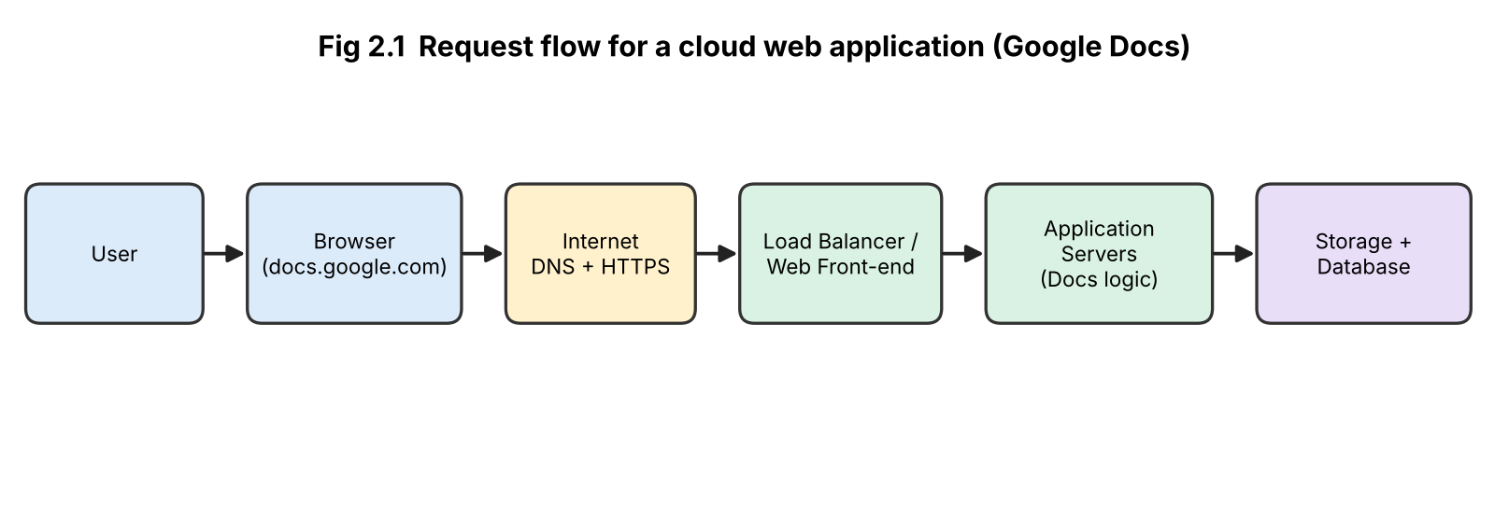
Figure 2.1 – Interaction between user, Internet and cloud components

Student B – Application Investigation (Google Docs)
Real-world cloud web application selected: Google Docs.

Major functions demonstrated and sequence of user actions
No. | User action | Where cloud access is involved
1 | Log in to docs.google.com | Authentication request sent to the cloud
2 | Create a blank document and type a title | Document created and stored in cloud storage
3 | Format text, insert a table and an image | Edits sent to the server and auto-saved
4 | Share with a partner (Editor) | Cloud permission list updated, notification sent
5 | Partner edits at the same time | Changes synchronised to both users in real time
6 | Open File → Version history | Previous versions retrieved from cloud
7 | Download as PDF | Cloud generates the file and sends it to the device

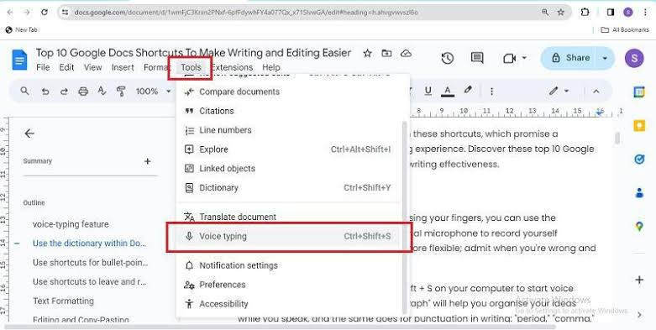
Screenshot 2.1 – Google Docs document being created and typed

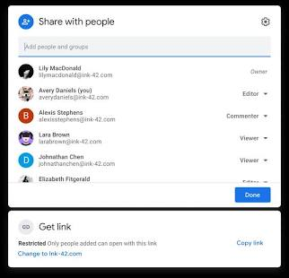
Screenshot 2.2 – Share dialog / version history of the document

Benefits of using the cloud application
- Access from any device and location; no installation.
- Automatic saving, so little risk of data loss.
- Real-time collaboration and one master copy.
- Automatic updates and backup by the provider; low cost.

Joint Evaluation – Cloud vs. Local-only installation
Factor | Application only on local computer | Application accessed through cloud
Accessibility | Only on that computer | Any device with Internet
Collaboration | Files must be e-mailed; multiple copies; conflicts | Real-time co-editing; one shared copy
Data safety | Lost if disk fails or the computer is stolen | Replicated and backed up by provider
Updates | Manual installation and licensing | Automatic and immediate
Scalability | Limited by the PC's CPU, RAM, disk | Elastic resources on demand
Cost | Hardware + licences + maintenance | Pay-as-you-use / subscription
Offline use | Works without Internet | Needs Internet (limited offline mode)

Conclusion: a local-only application limits mobility, sharing, backup and scalability. Its only advantage is offline operation and local control of data.

Q3 – Web APIs for Cloud Access

Shared Group Work
- Web API: an interface that lets one program communicate with another over HTTP using defined requests (GET, POST, PUT, DELETE) and responses (usually JSON).
- Cloud use: an application sends a request to a cloud endpoint and receives data/status, with no human interface needed.
- API selected: JSONPlaceholder – a free public REST API (https://jsonplaceholder.typicode.com) that returns sample posts and users.

Student A – API Design and Understanding
Purpose: JSONPlaceholder provides fake but realistic online data so that developers can test and learn REST API requests without creating a server or needing an API key.
Component | Description (this API)
Method | GET
Endpoint / URL | https://jsonplaceholder.typicode.com/posts/1
Headers | Accept: application/json
Parameters | Resource ID in the path (1, 2, ...); '/users/1' for user data
Response status | 200 OK (success), 404 Not Found (invalid id)
Response body | JSON object with userId, id, title, body

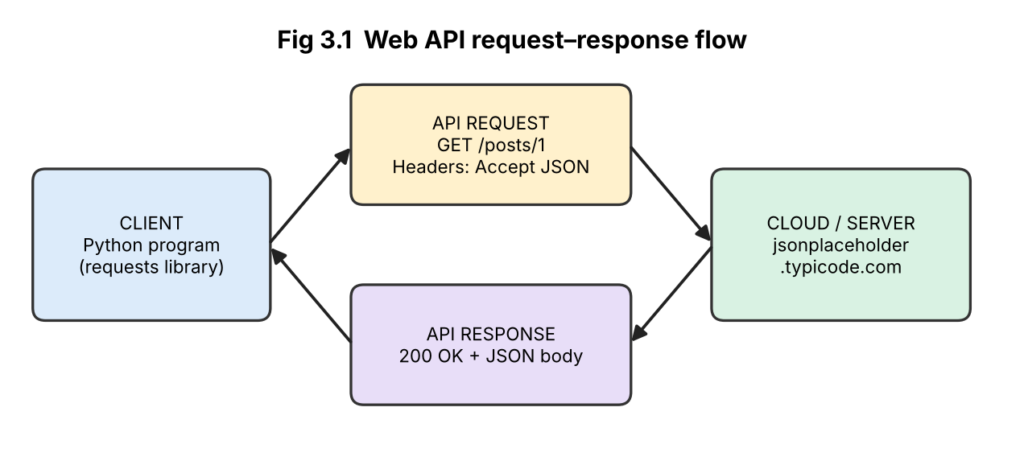
Figure 3.1 – API communication flow
Role | Explanation
Client | Python program that creates and sends the request and reads the response
API request | HTTP message containing the method, URL and headers asking for specific data
Cloud/server | Receives the request, finds the data, and prepares the reply
API response | Status code + JSON data returned to the client

How APIs enable programmatic cloud access: APIs expose cloud functions (storage, database, messaging) in a standard format, so programs can use them automatically, repeatedly and at scale, without a browser or human intervention.

Student B – Implementation and Evidence

Python program (api_client.py)
import requests

BASE = "https://jsonplaceholder.typicode.com"

def call(path):
url = BASE + path
print("REQUEST :", "GET", url)
r = requests.get(url, headers={"Accept": "application/json"}, timeout=10)
print("STATUS :", r.status_code, r.reason)
print("RESPONSE:", r.text[:300])
print("-" * 60)
return r

for p in ["/posts/1", "/users/1", "/posts/9999"]:
call(p)

Run with: pip install requests then python api_client.py

Requests tested and expected observations
No. | Request (input) | Status | Response (output)
1 | GET /posts/1 | 200 OK | JSON with userId = 1, id = 1, title ('sunt aut facere repellat provident ...') and a text body
2 | GET /users/1 | 200 OK | JSON with id = 1, name, username, email, address, phone, website, company
3 | GET /posts/9999 (invalid) | 404 Not Found | Empty JSON object { } – resource does not exist

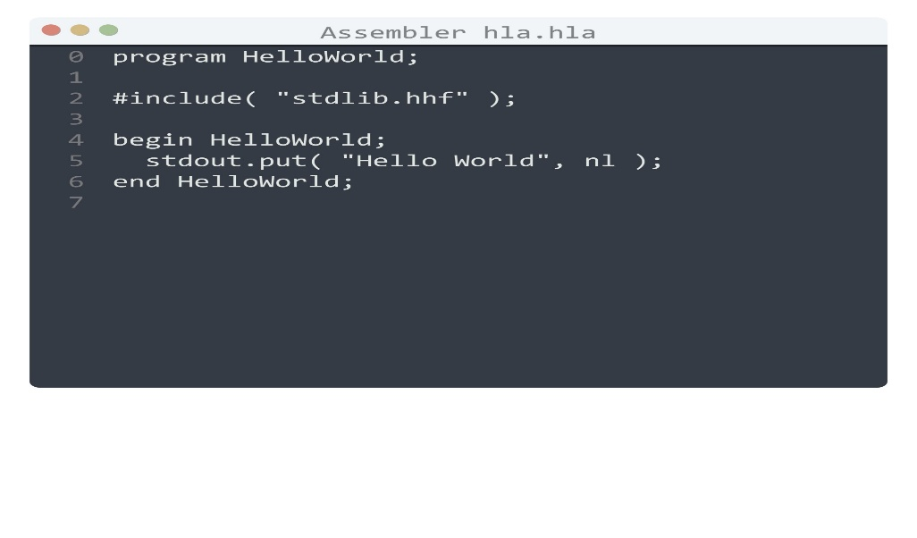
Screenshot 3.1 – Program code in the editor / IDLE

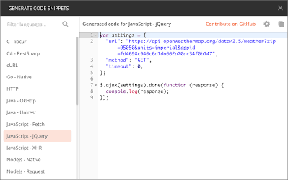Screenshot 3.2 – Terminal output showing the three requests and their responses (copy your actual output)

Analysis of observed results
- Different URLs return different resources from the same cloud server, showing resource-based (REST) design.
- Status codes tell the client the result (200 success, 404 error) so the program can react automatically.
- The response is machine-readable JSON, which a program can parse directly (r.json()).
- A valid request for existing data and an invalid one proved the importance of error handling.

Joint Analysis – Why is API access useful for many users/applications?
- Automation: thousands of programs can call the cloud at the same time with no manual work.
- Standard format: HTTP + JSON works across all languages and platforms.
- Scalability: the cloud adds servers to handle large request volumes.
- Integration: applications (mobile, web, IoT) share one backend service.
- Efficiency and control: only needed data is transferred; access can be secured and rate-limited with keys/tokens.

Q4 – Cloud Security and Network Access

Shared Group Work
Because cloud services are reached over the public Internet, security issues include unauthorised access, data interception, data leakage, weak passwords/phishing, insecure APIs and account hijacking. Authentication proves who the user is; authorization decides what that user may do; secure communication (TLS/HTTPS) protects data in transit.

Student B – Security Design

1. Four (or more) security considerations
No. | Consideration | Explanation
1 | Authentication | Strong passwords and multi-factor authentication (MFA) to confirm identity
2 | Authorization / access control | Least-privilege roles (IAM) so users only reach permitted resources
3 | Secure communication | HTTPS/TLS and VPN encrypt data in transit
4 | Data protection | Encryption at rest, backups, data-loss prevention
5 | Monitoring and logging | Audit logs and alerts to detect suspicious access
6 | API security | API keys/tokens, rate limiting, input validation

2. Authentication vs. authorization
 | Authentication | Authorization
Question answered | Who are you? | What are you allowed to do?
Example | Password + OTP login | Viewer can read the file but cannot edit or delete
Order | First step | Second step, after authentication

Importance of secure communication: without HTTPS an attacker on the same network (e.g. public Wi-Fi) could read or modify the data and steal passwords. TLS encrypts the traffic and verifies the server with a certificate.

3. Secure access flow
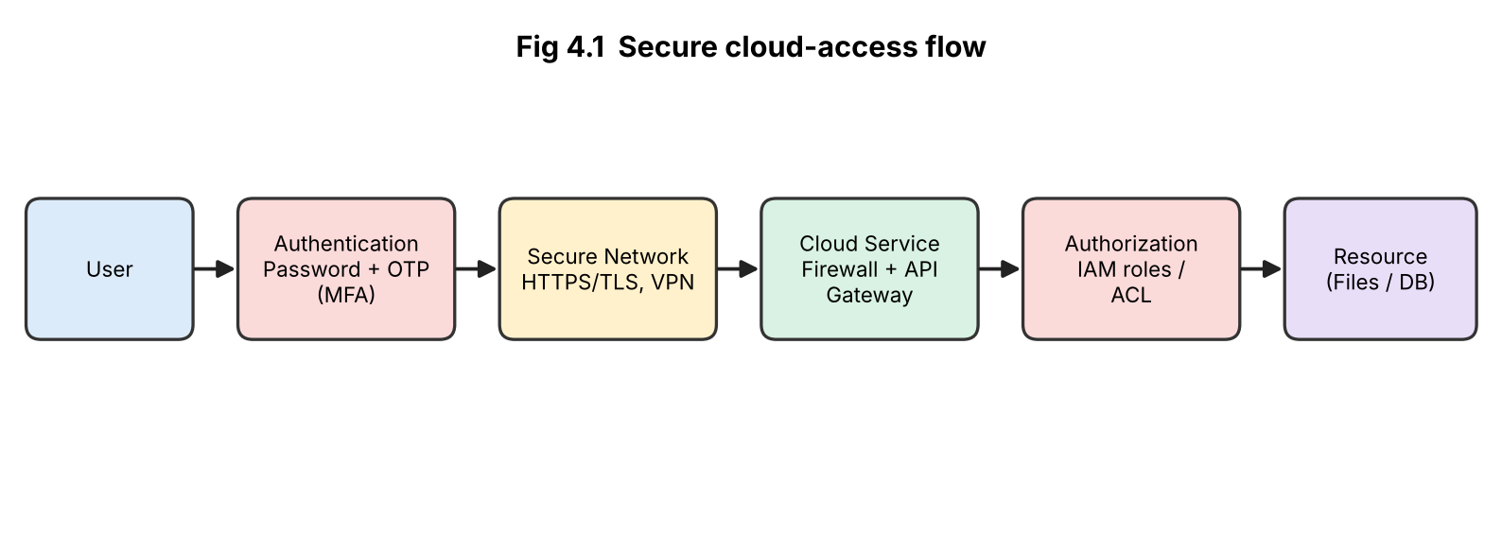
Figure 4.1 – User → Authentication → Network → Cloud Service → Authorization → Resource

4. Points of attack and security measures
No. | Point of attack | Threat | Suitable measure
1 | User login | Phishing, password guessing, stolen credentials | MFA, strong password policy, user awareness
2 | Network | Eavesdropping, man-in-the-middle on public Wi-Fi | HTTPS/TLS, VPN, avoid open Wi-Fi
3 | Cloud service / API | DDoS, API abuse, injection | Firewall, WAF, rate limiting, API gateway, input validation
4 | Authorization | Over-privileged accounts, privilege escalation | Least privilege, role-based access, periodic review
5 | Resource / data | Data leak, deletion, ransomware | Encryption at rest, versioned backups, audit logs

Student A – Security Investigation
Scenario investigated: a student accessing Google Drive on a college lab computer and on public Wi-Fi.
Authentication mechanism documented: Google account sign-in with 2-Step Verification (a code or prompt on the phone is required after the password).
Step | Action performed | Observation
1 | Opened Google Account → Security | 2-Step Verification option available
2 | Enabled 2-Step Verification with phone prompt | Account now needs password and second factor
3 | Signed in from another browser | Prompt/code requested on the phone before access was granted
4 | Checked the browser address bar | Padlock and 'https://' present – connection encrypted

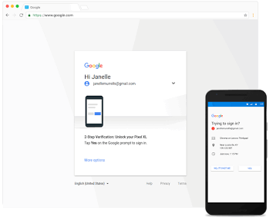
Screenshot 4.1 – 2-Step Verification enabled / sign-in prompt

Secure vs. insecure access (conceptual)
Aspect | Secure access | Insecure access
Login | Strong password + MFA | Weak or shared password only
Network | HTTPS, trusted network or VPN | HTTP, open public Wi-Fi
Permissions | Role-based, least privilege | Everyone has full access
Devices | Sign out, updated software | Stay logged in on shared PCs
Result | Data protected; attacks detected | Data theft, account takeover, loss of privacy

Effect of poor practices: stolen credentials let attackers read, delete or leak private files, impersonate users, spread malware and cause financial and reputation loss to individuals and organisations.

Joint Evaluation – Extra security needed compared with local applications
A local application is protected mostly by physical access, whereas cloud services are reachable by anybody on the Internet. Additional measures needed:
- Strong identity verification (MFA, single sign-on) because the 'perimeter' is the login page.
- Encryption of data in transit (TLS) and at rest.
- Fine-grained authorization (IAM, sharing permissions) and regular permission reviews.
- Network protection: firewalls, DDoS protection, VPN for administrative access.
- Logging, monitoring and alerting for access from unusual locations/devices.
- Secure API keys/tokens, backup and compliance with data-protection regulations.

Q5 – Collaboration Using Cloud-Based Services

Shared Group Work
- Platform selected: Google Drive + Google Docs.
- Shared space created: folder 'CO3_Group_Project' containing the document 'Cloud_Collaboration_Report'.
- Permissions configured: Student A – Editor; Student B – Editor on the document, Commenter on the final-report file; Faculty – Viewer (link restricted to named people).
- Collaborative editing performed simultaneously and recorded through screenshots and version history.

Student A – Collaboration Design

Requirements
Common storage for team files, simultaneous editing, controlled access, tracking of who changed what, ability to restore earlier versions, comments for feedback and access from any device.

Workflow
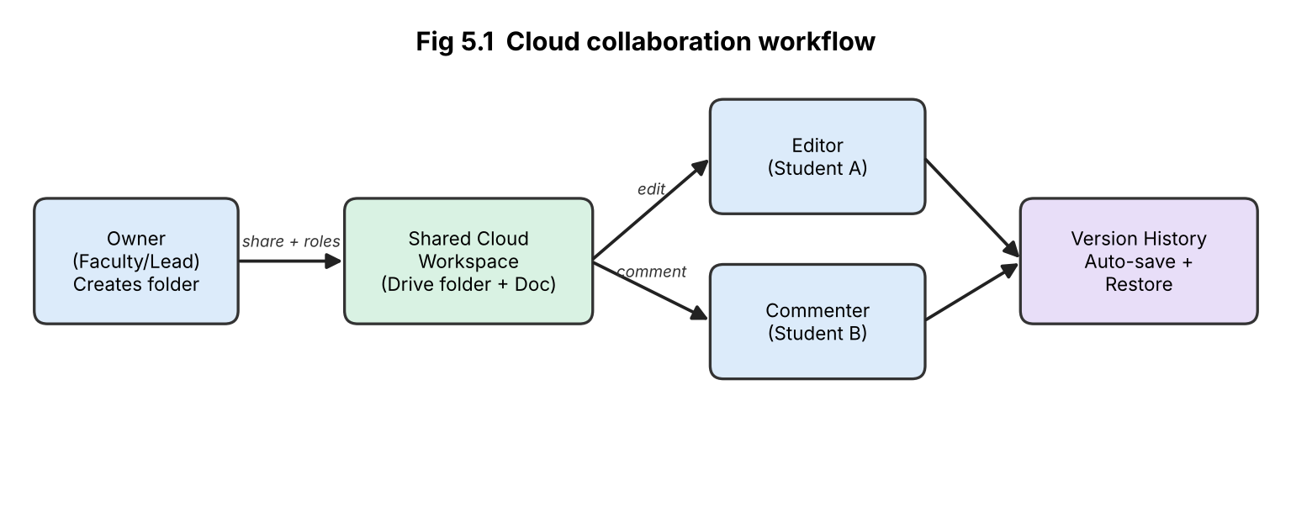
Figure 5.1 – Collaboration workflow
Concept | Explanation
Sharing | The owner shares a folder/document with specific e-mail IDs or a restricted link, instead of sending copies.
Concurrent access | Several users open the same file together; each change appears for all users within seconds and each user's cursor is shown.
Version control | Every edit is saved automatically; File → Version history shows who changed what and when and allows restoring an old version.
Permission management | Owner assigns Viewer, Commenter or Editor roles and can change or remove them at any time.

Roles and justification of permissions
User | Permission | Justification
Student A (owner / lead) | Owner/Editor | Creates the workspace and manages sharing
Student B | Editor | Needs to contribute content directly
Faculty | Viewer / Commenter | Can read and give feedback but cannot alter the content
Others | No access | Principle of least privilege protects the data

Student B – Collaborative Implementation

Activities performed and evidence
No. | Collaborative activity | Observation
1 | Both students edited different sections of the document at the same time | Changes appeared in real time with coloured cursors and names
2 | Added comments and suggested edits ('Suggesting' mode), then accepted/rejected them | Comment threads recorded author and time; accepted edits merged into the text
3 | Viewed version history and restored an earlier version | Edit history listed by user and timestamp; restore worked

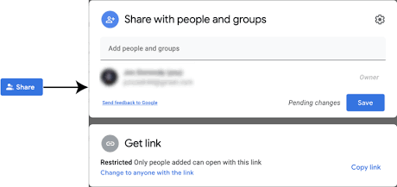 Screenshot 5.1 – Share settings showing users and their roles

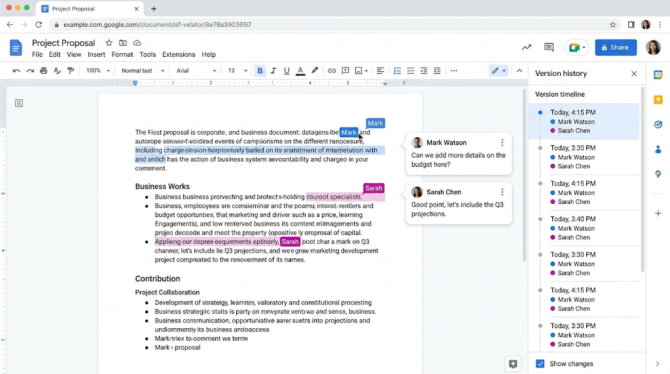
Screenshot 5.2 – Two users editing; comments / version history showing each contribution

Collaboration issue and solution
Issue: Both students edited the same paragraph at the same moment, and one student overwrote a sentence written by the other.
Solution: Assign separate sections to each person, use 'Suggesting' mode for edits to others' text, and use Version history to restore the lost sentence.

Cross-Understanding
How does cloud collaboration reduce multiple copies? All users work on one master file stored in the cloud and access it through a link or share setting, so no copies need to be e-mailed. Every change is applied to that single file, therefore there is no confusion about the 'latest version', no manual merging and less storage use.
Problems from incorrect sharing permissions: giving Editor rights to everyone allows accidental or malicious editing/deletion; 'Anyone with the link' exposes confidential data to outsiders; too few rights block work; removing the owner can cause loss of control. Hence permissions must be minimal and reviewed.

Q6 – Integrated Cloud Access and Collaboration Mini Investigation
Scenario selected: Cloud-Based Assignment Submission and Evaluation.

Student A – System Design
Item | Description
Problem | Assignments are submitted by e-mail/pen-drive/paper: files are lost, versions are confused, deadlines are hard to track and feedback is slow.
Users | Students (submit), Faculty (evaluate and give feedback), Class coordinator / admin (manage folders and reports).
Cloud access methods | Browser (laptop/lab PC), mobile app (smartphone), Google Forms link for submission; optional Google Drive/Sheets API for automation.
Cloud services required | Google Drive (storage), Google Forms (upload form), Google Sheets (marks register), Google Docs (comments), Google Account sign-in (authentication), Gmail notifications.

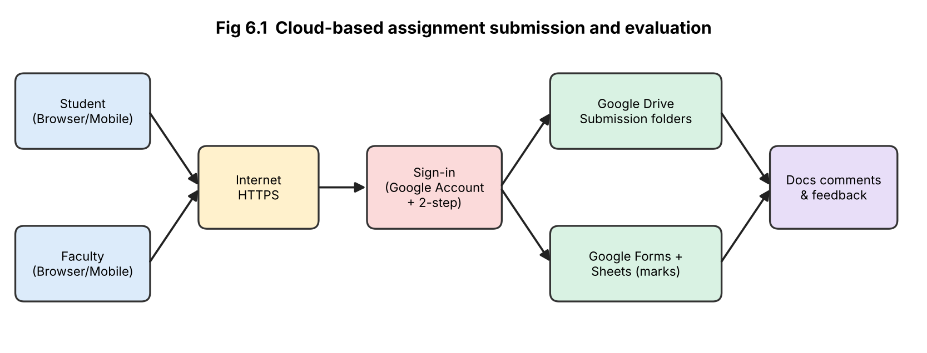
Figure 6.1 – System architecture

How users access the system
Users open the Google Form / Drive link in a browser or mobile app, sign in with their college Google account over HTTPS, and are shown only their permitted folders.

How users collaborate
Students upload the assignment to the shared Drive folder through the form; faculty open the file, insert comments and suggestions in Docs, enter marks in the shared Google Sheet and students see feedback and marks on their own devices without exchanging e-mails.

Student B – Evidence and Evaluation

Prototype / workflow
Step | Prototype action | Mechanism demonstrated
1 | Created Drive folder 'Assignments_CO3' with sub-folders per student | Cloud storage
2 | Created Google Form with file-upload question (sign-in required) | Cloud access + authentication
3 | Shared the folder: students – upload only; faculty – Editor | Permission settings
4 | Faculty opened a submission and added comments | Collaboration mechanism
5 | Faculty entered marks in a shared Google Sheet | Shared resource

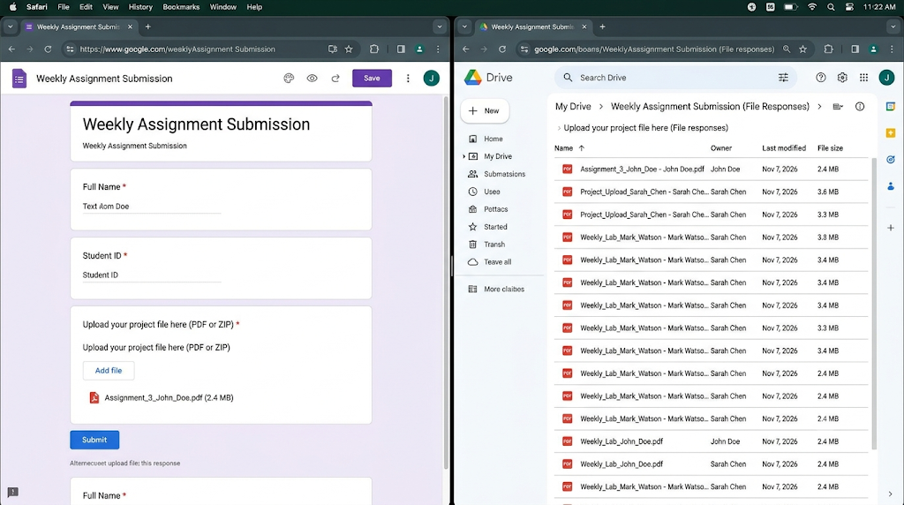Screenshot 6.1 – Google Form / Drive folder used for submission

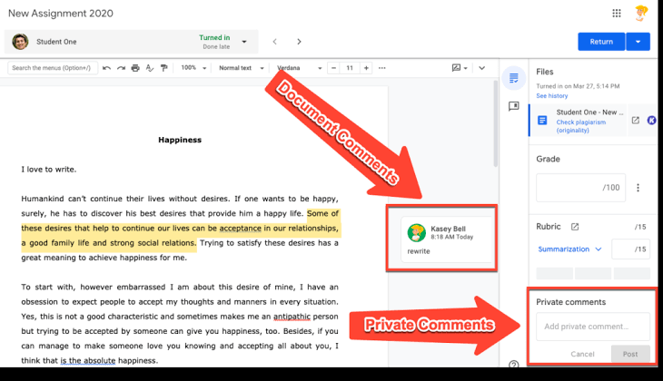 Screenshot 6.2 – Faculty comments / marks sheet

Testing with two user scenarios
Scenario | Test | Expected | Observed result
1 – Student | Submit PDF before the deadline from a mobile phone | Upload accepted; confirmation shown | Accepted; file visible in the folder
2 – Faculty | Open submission on a laptop, add comment and marks | Student sees the comment; marks saved | Comment and marks visible to the student
Extra | Student A tries to open Student B's file | Access denied | 'You need access' page appeared

Analysis, limitations and improvements
- Submission and feedback took minutes instead of days; one copy and a time-stamped record.
- Limitations: needs Internet, Drive storage quota, Google account for every user, large video files upload slowly.
- Improvements: automatic reminders (Apps Script / Calendar), plagiarism check, offline mode, role-based dashboards and backup export.

Joint Evaluation – Combining access and collaboration
Cloud access lets every participant reach the system anytime from any device, and collaboration lets them work on the same files together. Combined, they remove travel and waiting, eliminate multiple copies, give faster feedback, provide an audit trail of submissions and improve overall efficiency and transparency.

Q7 – Day-4 Design Challenge: Cloud-Based Collaborative Solution

Stage 1 – Independent Design Proposals
Item | Student A's proposal | Student B's proposal
Problem | Event planning in college (fests, seminars) is managed through WhatsApp groups and paper – information is scattered and tasks are missed | Registration and participant management for college events is manual, with errors and duplicate entries
Target users | Organising committee, volunteers, faculty coordinator | Participants, registration team, faculty coordinator
Cloud access method | Browser and mobile app | Mobile app and web form link
Cloud services | Google Drive, Docs, Sheets, Calendar | Google Forms, Sheets, Gmail, Drive
Collaboration mechanism | Shared Docs/Sheets task tracker with comments, assigned roles | Shared Sheet of registrations edited by the registration team
Basic architecture | Users → Browser/App → Internet → Google Workspace → Shared folder | Participants → Form → Sheet → Team via e-mail notification

Both initial proposals are retained as evidence (attach the handwritten/typed originals if required).

Stage 2 – Design Comparison Record
Criteria | Comparison
Where designs agree | Same platform family (Google Workspace), browser + mobile access, shared Sheets, faculty coordinator as common user.
Where they differ | A focuses on internal team planning; B focuses on external participant registration.
Strengths | A: strong task tracking and collaboration. B: automated data collection and notifications.
Weaknesses | A: no participant registration. B: weak collaboration among organisers; no role separation.
Security concerns | A: too many editors on one folder. B: personal data of participants in a sheet – needs restricted access and no public link.
Accessibility | Both work on mobile; B's form is easy for outsiders; A needs login for all users.
Collaboration requirements | Concurrent editing, comments, roles and history – stronger in A.
Missing components | Authentication policy, notifications/reminders, backup, reporting dashboard, API integration.
Ideas retained | A's shared planning workspace and roles + B's registration form, automated e-mail and Sheet.

Stage 3 – Joint Final Design: Cloud-Based Campus Event Management
Component | Final decision
Problem | Scattered, manual management of event planning and registration, causing delay, duplication and data errors.
Users | Organisers (admin), volunteers, participants, faculty coordinator.
Cloud access method | Web browser and mobile app (primary); Google Forms link for participants; Sheets/Calendar API for automation.
Network requirements | Internet via Wi-Fi/4G, HTTPS only; minimum about 1 Mbps; lab Wi-Fi with backup mobile data.
Cloud platform / service | Google Workspace on Google Cloud: Drive, Docs, Sheets, Forms, Calendar, Gmail.
Web application / API | Web apps for forms and documents; Sheets API / Apps Script to send confirmation mails and update the schedule.
Collaboration mechanism | Shared folder and Sheets with role-based editing, comments, version history and Calendar sharing.
Authentication / security | Google sign-in with 2-Step Verification for organisers; role-based permissions; no public edit links; HTTPS; audit through version history.
Data / resource sharing | Organisers: Editor; volunteers: Commenter/Editor on assigned sheets; faculty: Viewer; participants: form only.
Workflow | Participant submits form → data stored in Sheet → confirmation e-mail → organisers assign tasks → volunteers update status → coordinator monitors reports.

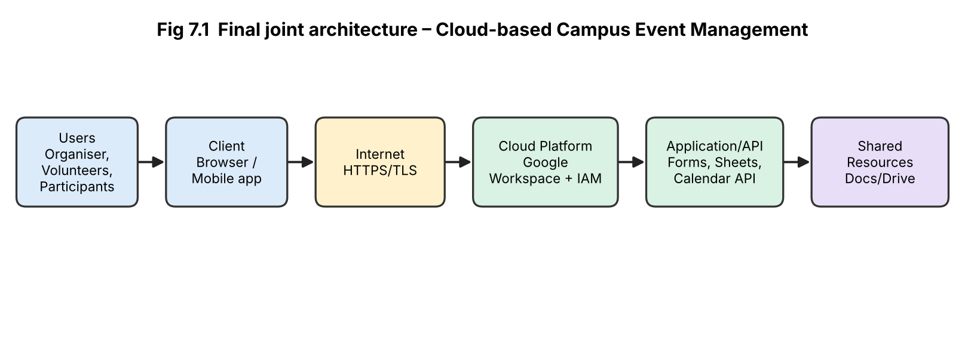
Figure 7.1 – Users → Client → Internet → Cloud Platform → Application/API → Shared Resources

Stage 4 – Validation

Student A – Technical Validation
- Access method: browser/mobile because it needs no installation, is device-independent and familiar to students.
- Platform choice: Google Workspace provides ready SaaS tools, real-time collaboration, role-based sharing, free education tier and APIs, which avoids building a custom server.
- Architecture: clients connect through HTTPS to the cloud platform; applications (Forms/Sheets) store data in shared resources; IAM controls who may read or edit.
- API/web access: Apps Script / Sheets API automate confirmation e-mails and calendar updates; web forms collect data.
- Suitability: low cost, scalable to hundreds of participants, easy to learn; limitations are dependence on the Internet and Google.

Student B – Experimental Validation (test cases)
TC | Test case | Condition | Expected result | Observed result
1 | Participant submits registration form | Mobile, 4G | Entry in Sheet; confirmation e-mail | Row added; e-mail received
2 | Organiser edits task sheet | Laptop, Wi-Fi | Change saved | Saved and visible instantly
3 | Two organisers edit at once | Two devices | Both edits shown, no overwrite | Both updates visible in real time
4 | Unauthorised user opens the organiser Sheet | Not shared | Access denied | 'Request access' shown
5 | Volunteer (Commenter) tries to edit | Role test | Edit blocked | Edit option disabled
6 | Internet disconnected during editing | Offline | Offline mode / sync later | Changes synced after reconnecting (offline mode on) or edit blocked

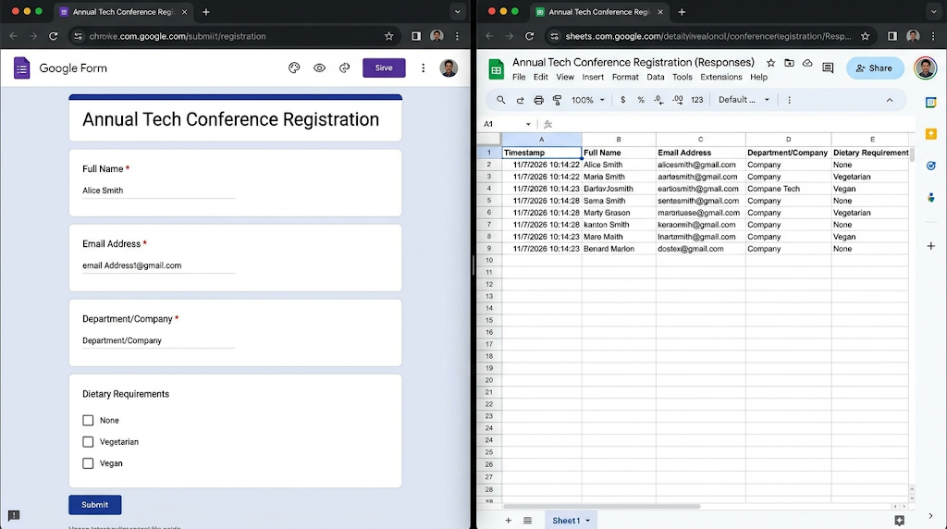
Screenshot 7.1 – Registration form and resulting Sheet

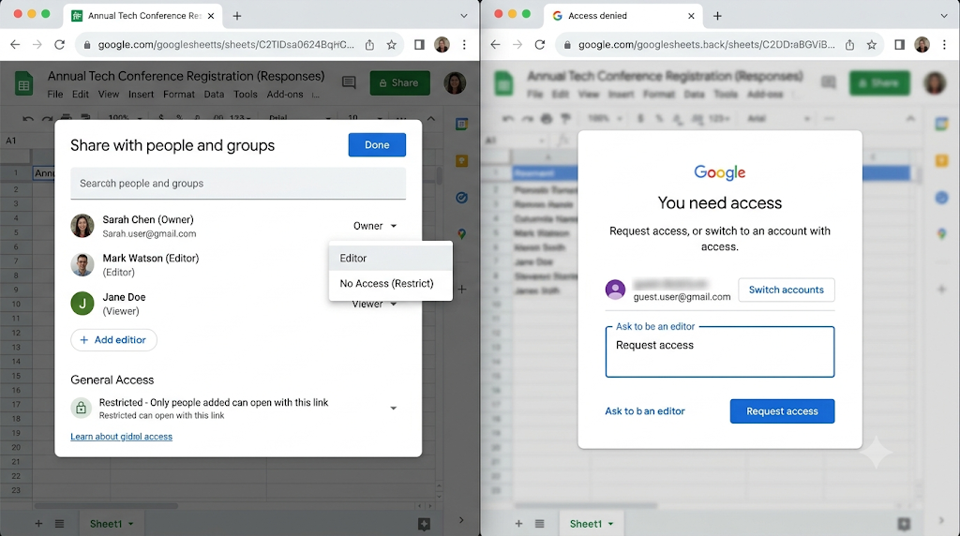Screenshot 7.2 – Sharing/role settings and access-denied test
Comparison of expected and observed behaviour: observed behaviour matched expectations in all functional tests; the only deviation was test 6, where editing without Internet worked only when offline mode was enabled beforehand.

Stage 5 – Cross-Defence
Student A – What experimental evidence supports the design? The form-to-sheet registration test, real-time multi-user editing, role-based access (denied access and blocked editing) and cross-device tests show that the design delivers access, collaboration and security as planned.
Student B – Why were this access and collaboration approach chosen? Participants and organisers use phones and laptops, so browser/mobile access removes installation barriers. Shared cloud documents with roles avoid multiple copies, give real-time updates and keep control of who may change what, at low cost.

Stage 6 – Joint Evaluation
Aspect | Evaluation
Benefits | Anytime/anywhere access, single source of truth, quick registration, reduced paperwork, low cost.
Access-related limitations | Needs Internet; mobile editing is less convenient; account needed for organisers.
Collaboration benefits | Real-time co-editing, comments, task visibility, version history.
Security risks | Account compromise, wrong sharing permissions, exposure of participants' personal data, phishing.
Scalability | Cloud handles hundreds of form entries; Sheets has size/row limits so large events need a database service (Cloud SQL/Firestore).
Possible improvements | MFA for all organisers, automated reminders, dashboard (Looker Studio), data backup, offline sync, custom web app using APIs.
Not appropriate when | Internet is unreliable/unavailable, data is highly confidential or legally restricted from leaving premises, or very large real-time systems need custom infrastructure.

Final Question – Characteristics a system designer must consider
Characteristic | What the designer should check
Connectivity and availability | Reliable Internet, uptime SLA, offline needs
Security and privacy | Authentication, encryption, data protection laws, data location
Access methods and devices | Browser/mobile/API, device variety, accessibility
Collaboration needs | Concurrent editing, roles, version control, auditability
Scalability and performance | Number of users, growth, response time
Cost | Subscription/usage cost, hidden costs, free-tier limits
Integration and APIs | Compatibility with existing systems, API availability
Reliability and backup | Data recovery, disaster recovery
Vendor lock-in and support | Ability to migrate data, support quality
User skills and training | Ease of use, training required

Contribution Record
Question | Student A – Primary Contribution | Student B – Primary Contribution | Joint Work
Q1 | Access method classification, architecture diagram, requirements | Practical access demo, screenshots, device tests, limitation | Methods study, service selection
Q2 | Platform components, mapping and interaction diagram | Google Docs investigation, screenshots, benefits | Platform comparison, cloud vs. local evaluation
Q3 | API purpose, request/response components, flow diagram | Python program, execution, 3 test requests, analysis | API selection, joint analysis
Q4 | Security investigation, 2-step verification, secure vs. insecure | Security considerations, secure flow, attack points and measures | Threat study, extra measures for cloud
Q5 | Collaboration workflow, roles, permission design | Shared workspace activities, evidence, issue and solution | Workspace creation, sharing settings
Q6 | Problem, users, services, architecture | Prototype, user scenario tests, limitations | Efficiency evaluation
Q7 | Individual proposal A, technical validation | Individual proposal B, test cases and experimental validation | Comparison, joint design, cross-defence, evaluation

Primary contribution does not mean exclusive responsibility; both students are accountable for the complete assignment.

Viva Preparation – Sample Answers
Transfer question | Answer
If Internet connectivity becomes unreliable, how would it affect cloud access? | Requests time out, uploads fail and real-time collaboration stops; only offline-enabled files can be used and changes sync after reconnection. Critical work needs offline mode or a backup connection.
If a shared cloud document is given editing permission to everyone, what problems could occur? | Accidental or malicious changes/deletion, data leakage, version confusion and no accountability; use least-privilege roles and version history.
If the API becomes unavailable, how would your application behave? | The request fails with a timeout or 5xx error; the program should handle exceptions, retry with back-off, show a message and use cached data.
If a user is authenticated but lacks permission, what should happen? | Access is denied (HTTP 403 / 'request access') and logged; authentication does not grant authorization.

